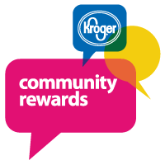
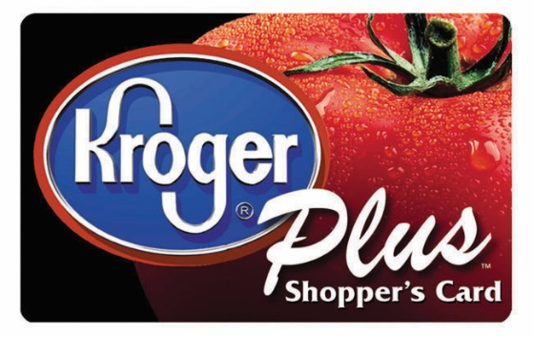
e
ATTENTION KROGER SHOPPERS!

Dear Parent/Guardians of Bruce Elementary Student:

SUPPORT BRUCE ELEMENTARY SCHOOL
BY ENROLLING TODAY!
1. VISIT KROGER.COM/COMMUNITYREWARDS
2. SIGN IN TO YOUR ACCOUNT OR CREATE ONE
3. CLICK ON “ENROLL NOW”
4. FIND BRUCE ELEMENTARY (VE596) AND CLICK “ENROLL”
5. THAT’S IT, KROGER WILL DONATE EVERY TIME YOU SHOP AND USE YOUR KROGER PLUS CARD!

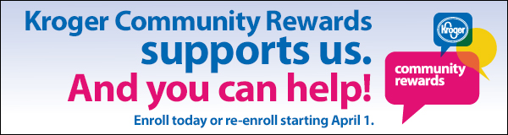
THANK YOU FOR YOUR CONTRIBUTIONS TO BRUCE ELEMENTARY!
1. Do you shop at Kroger?
2. Are you a Kroger Plus Card member?
If you answered YES, then you can help us when you shop at Kroger. Bruce and Kroger are community partners and with your help we have an opportunity to receive rewards for our school. By registering your Kroger Plus Card online or via phone and adding Bruce Elementary (VE596) as an organization to your card, the purchases made at Kroger will count towards rewards for our school. We encourage you to register online at krogercommunityrewards.com and follow the instructions below. Be sure to have your Kroger Plus card handy and register your card with your organization after you sign up. If you do not yet have a Kroger Plus card, they are available at the customer service desk at any Kroger.
- Simply type in the web address listed above, then click on Sign In/Register.
- If you are a new online customer, you must click on SIGN UP TODAY in the “New Customer?” box.
- Sign up for a Kroger Rewards Account by entering zip code, clicking on favorite store, enter you email address and creating a password, and agreeing to the terms and conditions.
- You will then get a message to check your email inbox and click on the link within the body of the email.
- Click on My Account and use your email address and password to proceed to the next step.
- Click on Edit Kroger Community Rewards information and input your Kroger Plus card number.
- Update or confirm your information.
- Enter NOP number or name of organization (see above), select organization from list and click on confirm.
- To verify you are enrolled correctly, you will see your organization’s name on the right side of your information page.
- REMEMBER, purchases will not count for our group until after you register your card(s).
- If you use your phone number at the register, call 1-800-576-4377, select option 4 to get your Kroger Plus card number.
- Members must swipe their registered Kroger Plus card or use the phone number that is related to their registered Kroger Plus card when shopping for each purchase to count.
Thank you in advance for your continued dedication to the students here at Bruce Elementary and we hope that you will join the partnership and assist us this school year by shopping at your local Kroger stores. We look forward to receiving all the rewards that your purchases will provide to us.
Sincerely,
Dr. Angela James
Principal

